Data624 – Homework2
Joseph Elikishvili

6.3

Chapter 6 talks about Linear regressions. Linear regresions are the most basic but very formidable models. They are easy to implement and can produce very good results. Chapter talks about the ordinary Linear regressions and then dives into PLS and extends conversation to Ridge Regression, Lasso and Elastic nets.
A chemical manufacturing process for a pharmaceutical product was discussed in Sect. 1.4. In this problem, the objective is to understand the relationship between biological measurements of the raw materials (predictors), measurements of the manufacturing process (predictors), and the response of product yield. Biological predictors cannot be changed but can be used to assess the quality of the raw material before processing. On the other hand, manufacturing process predictors can be changed in the manufacturing process. Improving product yield by 1% will boost revenue by approximately one hundred thousand dollars per batch:

A. Start R and use these commands to load the data: The matrix processPredictors contains the 57 predictors (12 describing the input biological material and 45 describing the process predictors) for the 176 manufacturing runs. yield contains the percent yield for each run.
We will get started by loading the necessary libraries, assigning the dataframe to a variable and exploring the dimentions of the dataset
library(AppliedPredictiveModeling)
library(caret)
data(ChemicalManufacturingProcess)
df = ChemicalManufacturingProcess
#summary(df)

B. A small percentage of cells in the predictor set contain missing values. Use an imputation function to fill in these missing values (e.g., see Sect. 3.8).
Next we will impute the missing values. We will evaluate data to see how much data is missing in each of the variables.
colSums(is.na(df))
## Yield BiologicalMaterial01 BiologicalMaterial02
## 0 0 0
## BiologicalMaterial03 BiologicalMaterial04 BiologicalMaterial05
## 0 0 0
## BiologicalMaterial06 BiologicalMaterial07 BiologicalMaterial08
## 0 0 0
## BiologicalMaterial09 BiologicalMaterial10 BiologicalMaterial11
## 0 0 0
## BiologicalMaterial12 ManufacturingProcess01 ManufacturingProcess02
## 0 1 3
## ManufacturingProcess03 ManufacturingProcess04 ManufacturingProcess05
## 15 1 1
## ManufacturingProcess06 ManufacturingProcess07 ManufacturingProcess08
## 2 1 1
## ManufacturingProcess09 ManufacturingProcess10 ManufacturingProcess11
## 0 9 10
## ManufacturingProcess12 ManufacturingProcess13 ManufacturingProcess14
## 1 0 1
## ManufacturingProcess15 ManufacturingProcess16 ManufacturingProcess17
## 0 0 0
## ManufacturingProcess18 ManufacturingProcess19 ManufacturingProcess20
## 0 0 0
## ManufacturingProcess21 ManufacturingProcess22 ManufacturingProcess23
## 0 1 1
## ManufacturingProcess24 ManufacturingProcess25 ManufacturingProcess26
## 1 5 5
## ManufacturingProcess27 ManufacturingProcess28 ManufacturingProcess29
## 5 5 5
## ManufacturingProcess30 ManufacturingProcess31 ManufacturingProcess32
## 5 5 0
## ManufacturingProcess33 ManufacturingProcess34 ManufacturingProcess35
## 5 5 5
## ManufacturingProcess36 ManufacturingProcess37 ManufacturingProcess38
## 5 0 0
## ManufacturingProcess39 ManufacturingProcess40 ManufacturingProcess41
## 0 1 1
## ManufacturingProcess42 ManufacturingProcess43 ManufacturingProcess44
## 0 0 0
## ManufacturingProcess45
## 0
We can see there is a number of missing values, but considering we are dealing with 2570 observations, it is a pretty low number, so imputation will have a very minimal effect.
We will use the missForest to do that, We could use a mean or median or any of the other techniques, but the library does allow us to impute more easily using a range of techniques
library(missForest)
df_imp1 = missForest(df)
## missForest iteration 1 in progress...done!
## missForest iteration 2 in progress...done!
## missForest iteration 3 in progress...done!
df_imp = df_imp1$ximp
Next we will separate out target variable yield from rest of the predictors
data = df_imp[,2:58]
target = df_imp[,1]

C. Split the data into a training and a test set, pre-process the data, and tune a model of your choice from this chapter. What is the optimal value of the performance metric?
Next we will split the data into training and test set. We will use 75/25 ratio to split between the training and test data.
training = createDataPartition( target, p=0.75 )
predictor_training = data[training$Resample1,]
target_training = target[training$Resample]
predictor_testing = data[-training$Resample1,]
target_testing = target[-training$Resample1]
Next we will use PLS model to train the model, we will center and scale the data using the preProc feauture.
ctrl <- trainControl(method = "cv", number = 10)
plsTune <- train(predictor_training, target_training,
method = "pls",
tuneLength = 20,
trControl = ctrl,
preProc = c("center", "scale"))
Next We will attempt to find out which of the variables are more important for our model. One way to do it is to evaluate the error metrics at each level, lets take a look
plsTune
## Partial Least Squares
##
## 132 samples
## 57 predictor
##
## Pre-processing: centered (57), scaled (57)
## Resampling: Cross-Validated (10 fold)
## Summary of sample sizes: 120, 117, 119, 120, 119, 118, ...
## Resampling results across tuning parameters:
##
## ncomp RMSE Rsquared MAE
## 1 1.384646 0.5156225 1.136070
## 2 1.382239 0.5520846 1.046958
## 3 1.485286 0.5883230 1.062383
## 4 1.802570 0.5458733 1.160633
## 5 2.296458 0.5181616 1.316696
## 6 2.467796 0.5106514 1.376702
## 7 2.728478 0.5006842 1.481419
## 8 2.986280 0.4903481 1.571238
## 9 3.317428 0.4881181 1.679301
## 10 3.629848 0.4852466 1.773767
## 11 3.835952 0.4806501 1.819963
## 12 3.877151 0.4642502 1.839989
## 13 3.802287 0.4624730 1.826397
## 14 3.725779 0.4573299 1.800685
## 15 3.635713 0.4621838 1.762159
## 16 3.555753 0.4655657 1.735499
## 17 3.506166 0.4664287 1.714587
## 18 3.374584 0.4654890 1.675443
## 19 3.389976 0.4675826 1.679073
## 20 3.344234 0.4724176 1.665095
##
## RMSE was used to select the optimal model using the smallest value.
## The final value used for the model was ncomp = 2.
Looks like n=3 yields the best RMSE = 1.405534

D. Predict the response for the test set. What is the value of the performance metric and how does this compare with the resampled performance metric on the training set?
Next we will use the model to make the predictions and will review the results.
pred_test = predict(plsTune, predictor_testing)
#pred_train = predict(plsTune, predictor_training)
pred_df <- data.frame(obs = target_testing, pred = pred_test)
defaultSummary(pred_df)
## RMSE Rsquared MAE
## 3.20626265 0.09498467 1.56550258
We get RMSE = 1.3138455 which is better then the above metric.

E. Which predictors are most important in the model you have trained? Do either the biological or process predictors dominate the list?
We can see that RMSE is minimal at n=3 RMSE = 1.460762 Next we can review the importance graphically.
plot(varImp(plsTune))
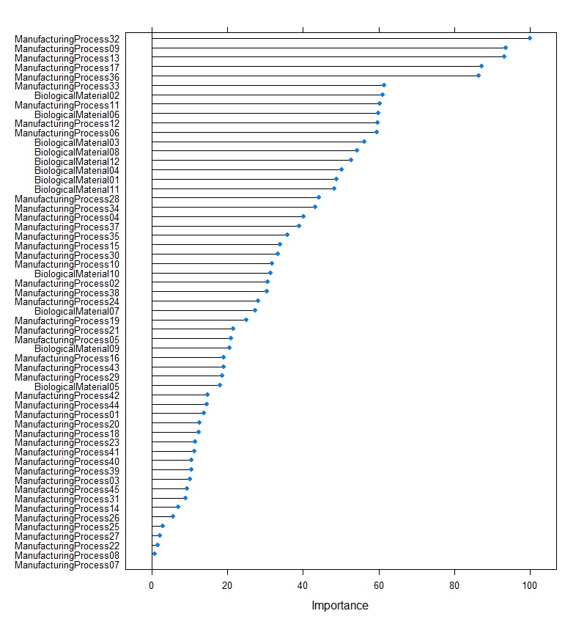
We can see that top predictors are mostly manufacturing processes.The first predictor of bialogical nature is #7, so it is safe to conclude that manufatucring processes have much higher impact on target yield.

F. Explore the relationships between each of the top predictors and the response. How could this information be helpful in improving yield in future runs of the manufacturing process?
We will take top 3 predictors and plot them against our target variable.
plot(data$ManufacturingProcess32, target)
abline(lm(target~data$ManufacturingProcess32),col="red",lwd=1.5)
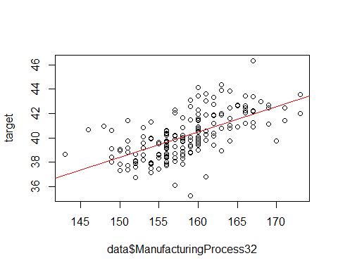
plot(data$ManufacturingProcess17, target)
abline(lm(target~data$ManufacturingProcess17),col="red",lwd=1.5)
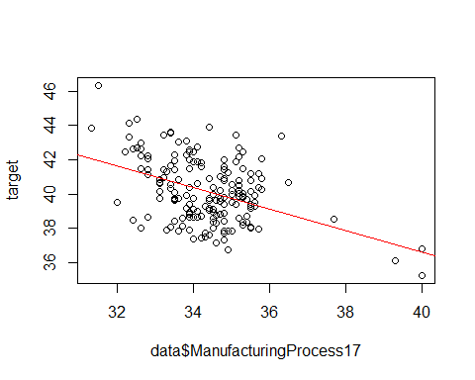
plot(data$ManufacturingProcess36, target)
abline(lm(target~data$ManufacturingProcess36),col="red",lwd=1.5)
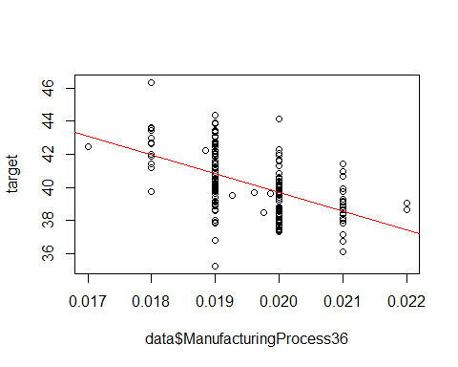
We can see that Manifacturing process32 has a positive corelation with the target and manufacturing process36 and 17 have negative corelation with the target. This means we could adjust the variables to potentially increase the yield.

Conclusion
Since we have conluded that manufacturing process variables are the most important and have the greatest impact on yield and we have identified the ones we are interested the most and have a corelation information to yield, we belive we can improve the oevral yield.
We would suggest to run more tests with various manifacturing process numbers and to model the most effecient combination which could boost the yield and boost the profits. It is highly likely that such a research would produce positive results and can have a significant impact on sales numbers.

7.2

Chapter 7 talks about non linear regressions. It goes over several models. Specifically MARS, SVM and K-NN. Exercise 7.2 goes over evaluating different models and comparing the results to better understand how to choose the appropriate model for a specific situation.
Friedman (1991) introduced several benchmark data sets create by simulation. One of these simulations used the following nonlinear equation to create data: y = 10 sin(??x1x2) + 20(x3 ??? 0.5)2 + 10x4 + 5x5 + N(0, ??2) Where the x values are random variables uniformly distributed between [0, 1] (there are also 5 other non-informative variables also created in the simulation). The package mlbench contains a function called mlbench.friedman1 that
We will preload the necessary libraries and generate the training and test data, then try the data on KNN, MARS and SVM and finally we will compare the results.
library(mlbench)
set.seed(200)
trainingData <- mlbench.friedman1(200, sd = 1)
## We convert the 'x' data from a matrix to a data frame
## One reason is that this will give the columns names.
trainingData$x <- data.frame(trainingData$x)
## Look at the data using
#featurePlot(trainingData$x, trainingData$y)
## or other methods.
## This creates a list with a vector 'y' and a matrix
## of predictors 'x'. Also simulate a large test set to
## estimate the true error rate with good precision:
testData <- mlbench.friedman1(5000, sd = 1)
testData$x <- data.frame(testData$x)

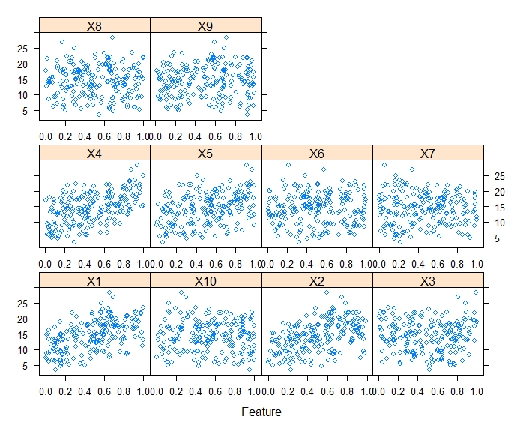

KNN
First we will use KNN model and view the results.
library(caret)
knnModel <- train(x = trainingData$x, y = trainingData$y, method = "knn", preProc = c("center", "scale"), tuneLength = 10)
knnModel
## k-Nearest Neighbors
##
## 200 samples
## 10 predictor
##
## Pre-processing: centered (10), scaled (10)
## Resampling: Bootstrapped (25 reps)
## Summary of sample sizes: 200, 200, 200, 200, 200, 200, ...
## Resampling results across tuning parameters:
##
## k RMSE Rsquared MAE
## 5 3.565620 0.4887976 2.886629
## 7 3.422420 0.5300524 2.752964
## 9 3.368072 0.5536927 2.715310
## 11 3.323010 0.5779056 2.669375
## 13 3.275835 0.6030846 2.628663
## 15 3.261864 0.6163510 2.621192
## 17 3.261973 0.6267032 2.616956
## 19 3.286299 0.6281075 2.640585
## 21 3.280950 0.6390386 2.643807
## 23 3.292397 0.6440392 2.656080
##
## RMSE was used to select the optimal model using the smallest value.
## The final value used for the model was k = 15.
Next we will use the trained model to make a prediction and review the RMSE
knnPred <- predict(knnModel, newdata = testData$x)
## The function 'postResample' can be used to get the test set
## perforamnce values
postResample(pred = knnPred, obs = testData$y)
## RMSE Rsquared MAE
## 3.1750657 0.6785946 2.5443169
We get RMSE = 3.17

MARS
Next we will take a look at MARS model
set.seed(101)
mars_grid = expand.grid(degree =1:2, nprune=seq(2,14,by=2))
marsTune = train(x= trainingData$x, y=trainingData$y, method='earth', tuneGrid=mars_grid, trControl = trainControl(method = "cv"))
marsTune
## Multivariate Adaptive Regression Spline
##
## 200 samples
## 10 predictor
##
## No pre-processing
## Resampling: Cross-Validated (10 fold)
## Summary of sample sizes: 180, 180, 180, 180, 180, 180, ...
## Resampling results across tuning parameters:
##
## degree nprune RMSE Rsquared MAE
## 1 2 4.417014 0.2350732 3.656244
## 1 4 2.606487 0.7293074 2.069700
## 1 6 2.192319 0.8094378 1.742533
## 1 8 1.700573 0.8889867 1.313446
## 1 10 1.640852 0.8967593 1.277871
## 1 12 1.641261 0.8950167 1.297462
## 1 14 1.642807 0.8964578 1.287479
## 2 2 4.417014 0.2350732 3.656244
## 2 4 2.606487 0.7293074 2.069700
## 2 6 2.218192 0.8021446 1.729223
## 2 8 1.750853 0.8789636 1.370531
## 2 10 1.449480 0.9177568 1.111537
## 2 12 1.316041 0.9299167 1.026115
## 2 14 1.321235 0.9300051 1.048692
##
## RMSE was used to select the optimal model using the smallest value.
## The final values used for the model were nprune = 12 and degree = 2.
We will review the Variable importance
#Variable Importance
varImp(marsTune)
## earth variable importance
##
## Overall
## X1 100.00
## X4 85.05
## X2 69.03
## X5 48.88
## X3 39.40
## X10 0.00
## X6 0.00
## X9 0.00
## X7 0.00
## X8 0.00
It appears MARS is only using x1-x5 to make a prediction.
Next we will make the prediction using MARS and review the results.
mars_pred = predict (marsTune, testData$x)
postResample(pred = mars_pred, obs = testData$y)
## RMSE Rsquared MAE
## 1.2803060 0.9335241 1.0168673
We get RMSE = 1.28 which is a definite improvement from KNN

SVM
Next we will use SVM model
set.seed(102)
svmTune = train(x= trainingData$x, y=trainingData$y, method='svmRadial', tuneLength = 14, trControl = trainControl(method = "cv"))
svmTune$finalModel
## Support Vector Machine object of class "ksvm"
##
## SV type: eps-svr (regression)
## parameter : epsilon = 0.1 cost C = 4
##
## Gaussian Radial Basis kernel function.
## Hyperparameter : sigma = 1
##
## Number of Support Vectors : 186
##
## Objective Function Value : -82.2151
## Training error : 0.009563
Lets review the variable importance
varImp(svmTune)
## loess r-squared variable importance
##
## Overall
## X4 100.0000
## X1 95.5047
## X2 89.6186
## X5 45.2170
## X3 29.9330
## X9 6.3299
## X10 5.5182
## X8 3.2527
## X6 0.8884
## X7 0.0000
Looks like x1-x5 are still the most important variables although in this case only x7 is not used, Also it appears x7 is the most important variable for SVM, although x7 was not even used by MARS
Lets review the results
svmPred <- predict(svmTune, newdata = testData$x)
postResample(pred = svmPred, obs = testData$y)
## RMSE Rsquared MAE
## 4.8618512 0.2038278 3.9582613
We get RMSE = 4.86

Conclusion
We conclude that MARS is the most accurate of the 3 models in this particular case. It resulted in the lowest RMSE of 1.28

7.5. Exercise 6.3 describes data for a chemical manufacturing process. Use the same data imputation, data splitting, and pre-processing steps as before and train several nonlinear regression models.
We will import imputation and data splitting code from 6.3 below.
library(AppliedPredictiveModeling)
library(caret)
data(ChemicalManufacturingProcess)
df = ChemicalManufacturingProcess
#summary(df)
library(missForest)
df_imp1 = missForest(df)
## missForest iteration 1 in progress...done!
## missForest iteration 2 in progress...done!
## missForest iteration 3 in progress...done!
## missForest iteration 4 in progress...done!
df_imp = df_imp1$ximp
data = df_imp[,2:58]
target = df_imp[,1]
training = createDataPartition( target, p=0.75 )
predictor_training = data[training$Resample1,]
target_training = target[training$Resample]
predictor_testing = data[-training$Resample1,]
target_testing = target[-training$Resample1]

KNN
We will start with KNN model and will measure the performance of the model.
knnModel_75 <- train(x = predictor_training, y = target_training, method = "knn", preProc = c("center", "scale"), tuneLength = 10)
knnModel_75
## k-Nearest Neighbors
##
## 132 samples
## 57 predictor
##
## Pre-processing: centered (57), scaled (57)
## Resampling: Bootstrapped (25 reps)
## Summary of sample sizes: 132, 132, 132, 132, 132, 132, ...
## Resampling results across tuning parameters:
##
## k RMSE Rsquared MAE
## 5 1.384146 0.3768763 1.078726
## 7 1.387710 0.3669445 1.109488
## 9 1.413321 0.3455230 1.141322
## 11 1.429472 0.3305082 1.160532
## 13 1.440057 0.3194528 1.172922
## 15 1.444468 0.3156153 1.177875
## 17 1.451980 0.3073148 1.189475
## 19 1.454195 0.3029005 1.191154
## 21 1.449979 0.3093282 1.187930
## 23 1.448196 0.3127738 1.188744
##
## RMSE was used to select the optimal model using the smallest value.
## The final value used for the model was k = 5.
Looks like we get the best RMSE metrics with n=5. We will use the model to make the prediction.
knnPred_75 <- predict(knnModel_75, newdata = predictor_testing)
postResample(pred = knnPred_75, obs = target_testing)
## RMSE Rsquared MAE
## 1.5495677 0.4973659 1.2286818
KNN based predictions have RMSE of 1.26.

Next we will use MARS model and measure the predictive performance.
mars_grid = expand.grid(degree =1:2, nprune=seq(2,14,by=2))
marsTune_75 = train(x = predictor_training, y = target_training, method='earth', tuneGrid=mars_grid, trControl = trainControl(method = "cv"))
marsTune_75
## Multivariate Adaptive Regression Spline
##
## 132 samples
## 57 predictor
##
## No pre-processing
## Resampling: Cross-Validated (10 fold)
## Summary of sample sizes: 120, 119, 119, 119, 118, 118, ...
## Resampling results across tuning parameters:
##
## degree nprune RMSE Rsquared MAE
## 1 2 1.388833 0.4162738 1.0937821
## 1 4 1.168918 0.5991866 0.9458691
## 1 6 1.265335 0.5485218 1.0050530
## 1 8 1.336531 0.4986164 1.0847822
## 1 10 1.217123 0.5945703 0.9454200
## 1 12 1.209208 0.5854100 0.9321785
## 1 14 1.198510 0.5961953 0.9504527
## 2 2 1.389164 0.4160174 1.0940570
## 2 4 1.192578 0.5690754 0.9631306
## 2 6 1.231714 0.5424268 0.9690872
## 2 8 1.233921 0.5448525 0.9706489
## 2 10 1.226324 0.5563709 0.9701000
## 2 12 1.281809 0.5263668 0.9913089
## 2 14 1.246238 0.5583326 0.9787434
##
## RMSE was used to select the optimal model using the smallest value.
## The final values used for the model were nprune = 4 and degree = 1.
We will review Variable importance
Next we will make the prediction using MARS and review the results.
marspred_75 = predict (marsTune_75, predictor_testing)
postResample(pred = marspred_75, obs = target_testing)
## RMSE Rsquared MAE
## 1.1724850 0.7060344 0.9081153
We have RMSE of 1.17 which is a slight improvement over KNN model.

Next we will use SVM model to make the prediction on the data set.
svmTune_75 = train(x = predictor_training, y = target_training, method='svmRadial', tuneLength = 14, trControl = trainControl(method = "cv"))
svmTune_75
## Support Vector Machines with Radial Basis Function Kernel
##
## 132 samples
## 57 predictor
##
## No pre-processing
## Resampling: Cross-Validated (10 fold)
## Summary of sample sizes: 118, 119, 120, 119, 117, 119, ...
## Resampling results across tuning parameters:
##
## C RMSE Rsquared MAE
## 0.25 1.749680 0.04943935 1.430692
## 0.50 1.746559 0.05023220 1.432773
## 1.00 1.743879 0.05216393 1.436458
## 2.00 1.744816 0.05261132 1.443579
## 4.00 1.744883 0.05257954 1.442838
## 8.00 1.744883 0.05257954 1.442838
## 16.00 1.744883 0.05257954 1.442838
## 32.00 1.744883 0.05257954 1.442838
## 64.00 1.744883 0.05257954 1.442838
## 128.00 1.744883 0.05257954 1.442838
## 256.00 1.744883 0.05257954 1.442838
## 512.00 1.744883 0.05257954 1.442838
## 1024.00 1.744883 0.05257954 1.442838
## 2048.00 1.744883 0.05257954 1.442838
##
## Tuning parameter 'sigma' was held constant at a value of 0.01305284
## RMSE was used to select the optimal model using the smallest value.
## The final values used for the model were sigma = 0.01305284 and C = 1.
Lets review the results
svmPred_75 <- predict(svmTune_75, newdata = predictor_testing)
postResample(pred = svmPred_75, obs = target_testing)
## RMSE Rsquared MAE
## 2.08911441 0.03096715 1.65214815
We get an RMSE of 2.09 with SVM which is slightly worse then the previous models.

A. Which nonlinear regression model gives the optimal re-sampling and test set performance?
Out of 3 non linear models we used, MARS has the best accuracy with RMSE of 1.17

B. Which predictors are most important in the optimal nonlinear regression model? Do either the biological or process variables dominate the list? How do the top ten important predictors compare to the top ten predictors from the optimal linear model?
Let’s review predictor importance of MARS and KNN models as they have the best RSME scores.

KNN top predictors
#plot(varImp(knnModel))

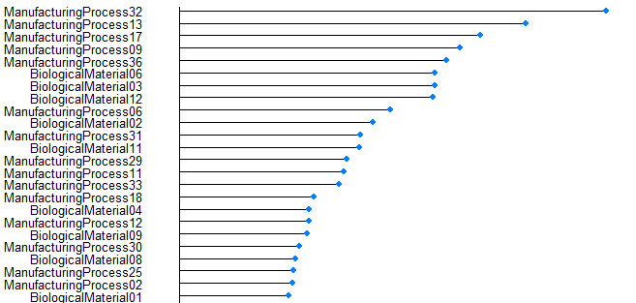

MARS top predictors
#plot(varImp(marsTune))
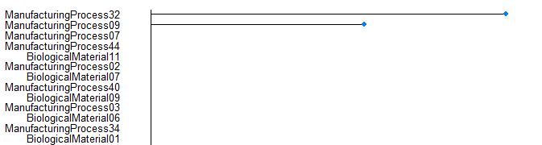
Interestingly enough we see pretty much same predictors selected by both models. Knn shows same top picks as PLS and MARS model although only selects top 2 predictors, still has the same top 2 as PLS. ManufacturingProcess32 and manifacturingprocess09 remain top predictors and interestingly enough MARS was able to predict using only those 2 predictors and had comparable results to PLS, which means we could very well need only 2 predictors to capture most of the predictions.

C. Explore the relationships between the top predictors and the response for the predictors that are unique to the optimal nonlinear regression model. Do these plots reveal intuition about the biological or process predictors and their relationship with yield?
We have the same predictors as PLS, so we will use those
plot(data$ManufacturingProcess32, target)
abline(lm(target~data$ManufacturingProcess32),col="red",lwd=1.5)
plot(data$ManufacturingProcess09, target)
abline(lm(target~data$ManufacturingProcess09),col="red",lwd=1.5)
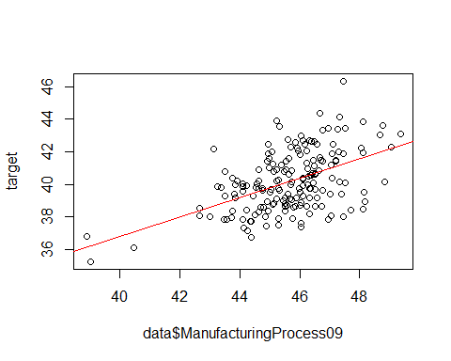
Both predictors have positive corelation. Lets check the exact corelation
cor(data$ManufacturingProcess32, target)
## [1] 0.6083321
cor(data$ManufacturingProcess09, target)
## [1] 0.5034705

Conclusion
It appears that we have come to the same conclusion using non-linear models, which is a good indicator that PLS was not the worst choice for this task, We also identified that most of the predictions are coming from 2 top predictors and therefore any potential optimization work should be directed at those 2 predictors.

8.1
We will load data from 7.2 as per instructions.
library(mlbench)
set.seed(202)
simulated <- mlbench.friedman1(200, sd = 1)
simulated <- cbind(simulated$x, simulated$y)
simulated <- as.data.frame(simulated)
colnames(simulated)[ncol(simulated)] <- "y"

Fit a random forest model to all of the predictors, then estimate the variable importance scores:
library(randomForest)
library(caret)
model1 <- randomForest(y ~ ., data = simulated,
importance = TRUE,
ntree = 1000)
rfImp1 <- varImp(model1, scale = FALSE)
rfImp1
## Overall
## V1 4.39203636
## V2 8.54848388
## V3 1.36216360
## V4 10.09353398
## V5 2.35489781
## V6 -0.02689475
## V7 0.12457474
## V8 0.09277256
## V9 0.16901670
## V10 0.27216301
We can see that V1-V5 got much higher weights then V6-V10. By rough estimate we see a cumulative absolute weight of 25 for V1-V5 and an absolute cumulative weight of about 0.6 for V6-V10, this shows a significant relative difference Did the random forest model significantly use the uninformative predictors (V6 - V10)?

B. Now add an additional predictor that is highly correlated with one of the informative predictors. For example:
duplicate1 <- simulated$V1 + rnorm(200) * .1
#cor(simulated$duplicate1, simulated$V1)
Fit another random forest model to these data. Did the importance score for V1 change? What happens when you add another predictor that is also highly correlated with V1?
Lets go ahead and add the predictor to the data and re run the model
simulated$V11 = duplicate1
model2 <- randomForest(y ~ ., data = simulated,
importance = TRUE,
ntree = 1000)
rfImp2 <- varImp(model2, scale = FALSE)
rfImp2
## Overall
## V1 2.98364173
## V2 8.54289551
## V3 1.14067755
## V4 9.81482100
## V5 1.96513668
## V6 0.06254938
## V7 0.04282992
## V8 -0.06792789
## V9 0.18501386
## V10 0.28748225
## V11 2.89615317
We can see that V1 score has decreased, as the highly correlated predictor has been added. So we can conclude that the importance of the variable will decrease if there are highly correlated predictors present.

C. Use the cforest function in the party package to fit a random forest model using conditional inference trees. The party package function varimp can calculate predictor importance. The conditional argument of that function toggles between the traditional importance measure and the modified version described in Strobl et al. (2007). Do these importance show the same pattern as the traditional random forest model?
Lets run the model and review results
library(party)
rf1 = cforest(y ~., data =simulated[, 1:11], controls = cforest_control(ntree=1000))
rf2 = cforest(y ~., data =simulated, controls = cforest_control(ntree=1000))
imp1= varImp(rf1)
imp2= varImp(rf2)
imp1
## Overall
## V1 3.82003646
## V2 8.87387156
## V3 0.27458632
## V4 12.15246108
## V5 2.35611066
## V6 -0.03701611
## V7 -0.04672204
## V8 -0.03247095
## V9 0.07055175
## V10 0.21559424
imp2
## Overall
## V1 2.22847968
## V2 8.58912042
## V3 0.25889259
## V4 11.68161820
## V5 2.14115049
## V6 0.02640094
## V7 0.03121931
## V8 -0.01765752
## V9 0.05869952
## V10 0.21726427
## V11 2.64645437
We can see a similar behavior, V1-V5 have the highest importance while V6-V10 have the lower importance.

D. Repeat this process with different tree models, such as boosted trees and Cubist. Does the same pattern occur?
Lets try to generate results with Bagged Trees
library(ipred)
bt1 = bagging(y ~., data = simulated[, 1:11], nbag =50)
bt2 = bagging(y ~., data = simulated, nbag =50)
imp_bt1= varImp(bt1)
imp_bt2= varImp(bt2)
imp_bt1
## Overall
## V1 1.7963534
## V10 0.8297850
## V2 1.7139834
## V3 1.4817921
## V4 2.2994632
## V5 1.8843893
## V6 0.7113112
## V7 0.8754050
## V8 0.7182479
## V9 0.7914967
imp_bt2
## Overall
## V1 1.8856164
## V10 0.8520204
## V11 1.6965504
## V2 1.8348689
## V3 1.0828712
## V4 2.1927115
## V5 1.8026756
## V6 0.5738606
## V7 0.7198832
## V8 0.8377508
## V9 0.8205739
Bagged Trees are changing some of the results, we can see that V10 has a higher then normal importance and we see a more distributed importance then before, V6-V10 are no long just a franction of the V1-V5 importance levels.
Next we will try Cubist model
library(Cubist)
cb1 = cubist(simulated[, 1:10], simulated$y, committees =100)
cb2 = cubist(simulated[, names(simulated) !="y"], y=simulated$y, committees =100 )
imp_cb1 = varImp(cb1)
imp_cb2 = varImp(cb2)
imp_cb1
## Overall
## V3 50.0
## V1 53.0
## V2 65.0
## V4 52.5
## V5 28.5
## V7 11.5
## V9 5.5
## V10 2.0
## V8 0.5
## V6 0.0
imp_cb2
## Overall
## V3 51.5
## V1 50.0
## V2 64.0
## V4 56.5
## V5 30.0
## V11 21.5
## V8 1.0
## V9 4.0
## V7 6.0
## V6 3.5
## V10 2.5
Cubist model is similar to the first models V1-V5 have a much higher importance then V6-V10, although we see that V7 has moved up relative to V6-V10.

8.3. In stochastic gradient boosting the bagging fraction and learning rate will govern the construction of the trees as they are guided by the gradient. Although the optimal values of these parameters should be obtained through the tuning process, it is helpful to understand how the magnitudes of these parameters affect magnitudes of variable importance. Figure 8.24 provides the variable importance plots for boosting using two extreme values for the bagging fraction (0.1 and 0.9) and the learning rate (0.1 and 0.9) for the solubility data. The left-hand plot has both parameters set to 0.1, and the right-hand plot has both set to 0.9:
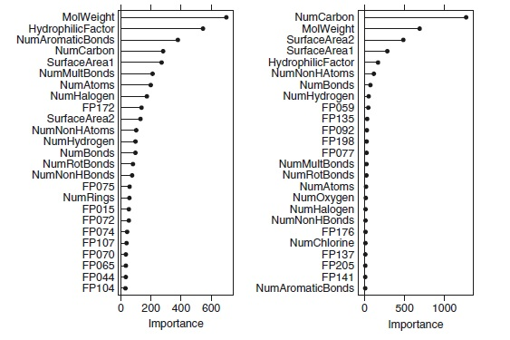

(a) Why does the model on the right focus its importance on just the first few of predictors, whereas the model on the left spreads importance across more predictors?
The model on the right focuses its importance on just first few predictors because of the fact that as the learning rate increases, it becomes more greedy and will use fewer predictors. Also another reason is due to bagging fraction, the higher is the fraction, less predictors will be identified as important.

(b) Which model do you think would be more predictive of other samples?
The left model is using more predictors, while the model on teh right relies mostly on top 3 predictors, so assumption can be made the the model on the left will be more accurate.

(c) How would increasing interaction depth affect the slope of predictor importance for either model in Fig. 8.24?
Increasing Interaction depth will most likely force the model to spread the importance across predictors, so the model on the right will probably benefit more from it, but as a result, more weight will be increased to predictors lagging importance.

8.7 Refer to Exercises 6.3 and 7.5 which describe a chemical manufacturing process. Use the same data imputation, data splitting, and pre-processing steps as before and train several tree-based models:
We will import imputation and data splitting code from 6.3 below.
library(AppliedPredictiveModeling)
library(caret)
data(ChemicalManufacturingProcess)
df = ChemicalManufacturingProcess
#summary(df)
library(missForest)
df_imp1 = missForest(df)
## missForest iteration 1 in progress...done!
## missForest iteration 2 in progress...done!
## missForest iteration 3 in progress...done!
## missForest iteration 4 in progress...done!
df_imp = df_imp1$ximp
data = df_imp[,2:58]
target = df_imp[,1]
training = createDataPartition( target, p=0.75 )
predictor_training = data[training$Resample1,]
target_training = target[training$Resample]
predictor_testing = data[-training$Resample1,]
target_testing = target[-training$Resample1]
ctrl <- trainControl(method = "cv", number = 10)
We will use several models and will evaluate the results.

Regression tree
First we will use Single Tree model and evaluate the results.
#Tune
rt_grid <- expand.grid(maxdepth= seq(1,10,by=1))
rt_Tune <- train(x = predictor_training, y = target_training, method = "rpart2", metric = "Rsquared", tuneGrid = rt_grid, trControl = ctrl)
#Predict
rt_pred = predict(rt_Tune, predictor_testing)
postResample(pred = rt_pred, obs = target_testing)
## RMSE Rsquared MAE
## 1.4295136 0.4200005 1.0512342
Next we will use Random forest model to evaluate
#Tune
rf_grid <- expand.grid(mtry=seq(2,38,by=3))
rf_Tune <- train(x = predictor_training, y = target_training, method = "rf", tuneGrid = rf_grid, metric = "Rsquared", importance = TRUE, trControl = ctrl)
#Predict
rf_pred = predict(rt_Tune, predictor_testing)
postResample(pred = rt_pred, obs = target_testing)
## RMSE Rsquared MAE
## 1.4295136 0.4200005 1.0512342
Finally lets take a look at Cubist model
#Tune
cube_grid <- expand.grid(committees = c(1, 5, 10, 20, 50), neighbors = c(0, 1, 3, 5))
cube_Tune <- train(x = predictor_training, y = target_training, method = "cubist", metric = "Rsquared", tuneGrid = cube_grid, trControl = ctrl)
#Predict
cube_pred = predict(cube_Tune, predictor_testing)
postResample(pred = cube_pred, obs = target_testing)
## RMSE Rsquared MAE
## 0.8556065 0.7741709 0.6578451
It appear that Cubist model has the best RMSE score, it is an improvement over MARS scores and over PLS scores that we had.

(b) Which predictors are most important in the optimal tree-based regression model? Do either the biological or process variables dominate the list? How do the top 10 important predictors compare to the top 10 predictors from the optimal linear and nonlinear models?
Lets go ahead and review the predictor importance of cubist model
plot(varImp(cube_Tune), top=10, scales = list(y = list(cex = 0.8)))
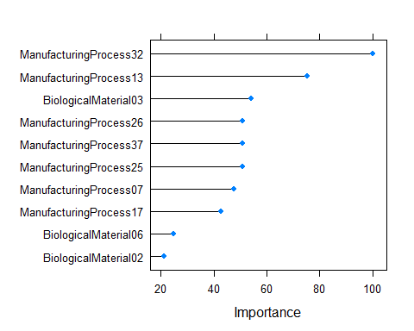
We can see that Manufacturing process32 made the top of the list which is not a surprise as we already established that it is the most important predictor, followed by Manufacturingprocess17. One thing to notice is that Cubist model heavily relies on top 2 predictors vs PLS, but we saw similar behavior with MARS. One surprise is that Cubist is using Manufacturer process 17 and not 9 like MARS, but then again we saw similar usage with PLS and other models.

C. Plot the optimal single tree with the distribution of yield in the terminal nodes. Does this view of the data provide additional knowledge about the biological or process predictors and their relationship with yield?
Next we will plot the OPtimal Sinlge tree
library(party)
library(partykit)
plot(as.party(rt_Tune$finalModel),gp=gpar(fontsize=11))
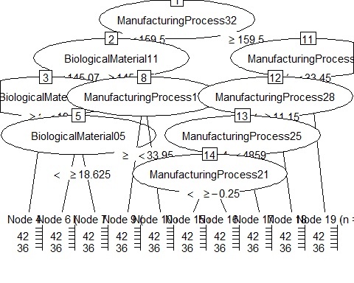
As expected we can see the the top predictors are Manufacture related processes. Manufacturing process32 is at the top only few Biological processes affect target in any meaningful way.

Conclusion.
At this point we have established that manufacturer processes have a much larger impacting role towards yield then biological factors, Cubist model is the latest and strongest confirmation of that, so any further study should be focused on finding optimal values for manufacturing processes.

Market Basket Analysis
Lets go ahead and load the data and have a quick look
library(arules)
library(arulesViz)
library(datasets)
df = read.transactions("c:/data/GroceryDataSet.csv", sep = ",")
summary(df)
## transactions as itemMatrix in sparse format with
## 9835 rows (elements/itemsets/transactions) and
## 169 columns (items) and a density of 0.02609146
##
## most frequent items:
## whole milk other vegetables rolls/buns soda
## 2513 1903 1809 1715
## yogurt (Other)
## 1372 34055
##
## element (itemset/transaction) length distribution:
## sizes
## 1 2 3 4 5 6 7 8 9 10 11 12 13 14 15
## 2159 1643 1299 1005 855 645 545 438 350 246 182 117 78 77 55
## 16 17 18 19 20 21 22 23 24 26 27 28 29 32
## 46 29 14 14 9 11 4 6 1 1 1 1 3 1
##
## Min. 1st Qu. Median Mean 3rd Qu. Max.
## 1.000 2.000 3.000 4.409 6.000 32.000
##
## includes extended item information - examples:
## labels
## 1 abrasive cleaner
## 2 artif. sweetener
## 3 baby cosmetics
We will next view top 30 items
itemFrequencyPlot(df,topN=30,type="absolute")
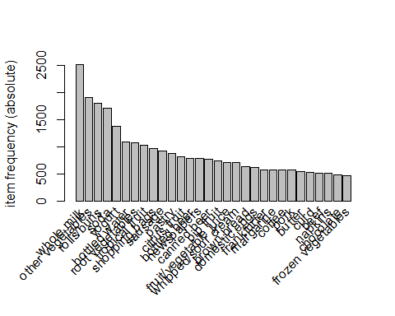
Next lets use apriori function and look for rules we will use support minimum of 0.001 and confidence of of 0.8
rules <- apriori(df, parameter = list(supp = 0.001, conf = 0.8))
## Apriori
##
## Parameter specification:
## confidence minval smax arem aval originalSupport maxtime support minlen
## 0.8 0.1 1 none FALSE TRUE 5 0.001 1
## maxlen target ext
## 10 rules FALSE
##
## Algorithmic control:
## filter tree heap memopt load sort verbose
## 0.1 TRUE TRUE FALSE TRUE 2 TRUE
##
## Absolute minimum support count: 9
##
## set item appearances ...[0 item(s)] done [0.00s].
## set transactions ...[169 item(s), 9835 transaction(s)] done [0.00s].
## sorting and recoding items ... [157 item(s)] done [0.00s].
## creating transaction tree ... done [0.00s].
## checking subsets of size 1 2 3 4 5 6 done [0.01s].
## writing ... [410 rule(s)] done [0.00s].
## creating S4 object ... done [0.00s].
options(digits=2)
inspect(rules[1:10])
## lhs rhs support confidence lift count
## [1] {liquor,
## red/blush wine} => {bottled beer} 0.0019 0.90 11.2 19
## [2] {cereals,
## curd} => {whole milk} 0.0010 0.91 3.6 10
## [3] {cereals,
## yogurt} => {whole milk} 0.0017 0.81 3.2 17
## [4] {butter,
## jam} => {whole milk} 0.0010 0.83 3.3 10
## [5] {bottled beer,
## soups} => {whole milk} 0.0011 0.92 3.6 11
## [6] {house keeping products,
## napkins} => {whole milk} 0.0013 0.81 3.2 13
## [7] {house keeping products,
## whipped/sour cream} => {whole milk} 0.0012 0.92 3.6 12
## [8] {pastry,
## sweet spreads} => {whole milk} 0.0010 0.91 3.6 10
## [9] {curd,
## turkey} => {other vegetables} 0.0012 0.80 4.1 12
## [10] {rice,
## sugar} => {whole milk} 0.0012 1.00 3.9 12

Our top rule is for liquor, it has a support of 0.0019, confidence of 90% and lift of 11.2. Our top 10 rules have pretty good confidence levels on average above 80%

